HAPPY VALENTINE BIRTHDAY
MARGIE!
FEB 14, 2016
MARGIE's 5th BIRTHDAY!
FOREVER MARGIE!
THEN Margie, my BEAUTIFUL DREAMER. NOW
This is a grandma??
Our Grandson Dylan (& Gunner)
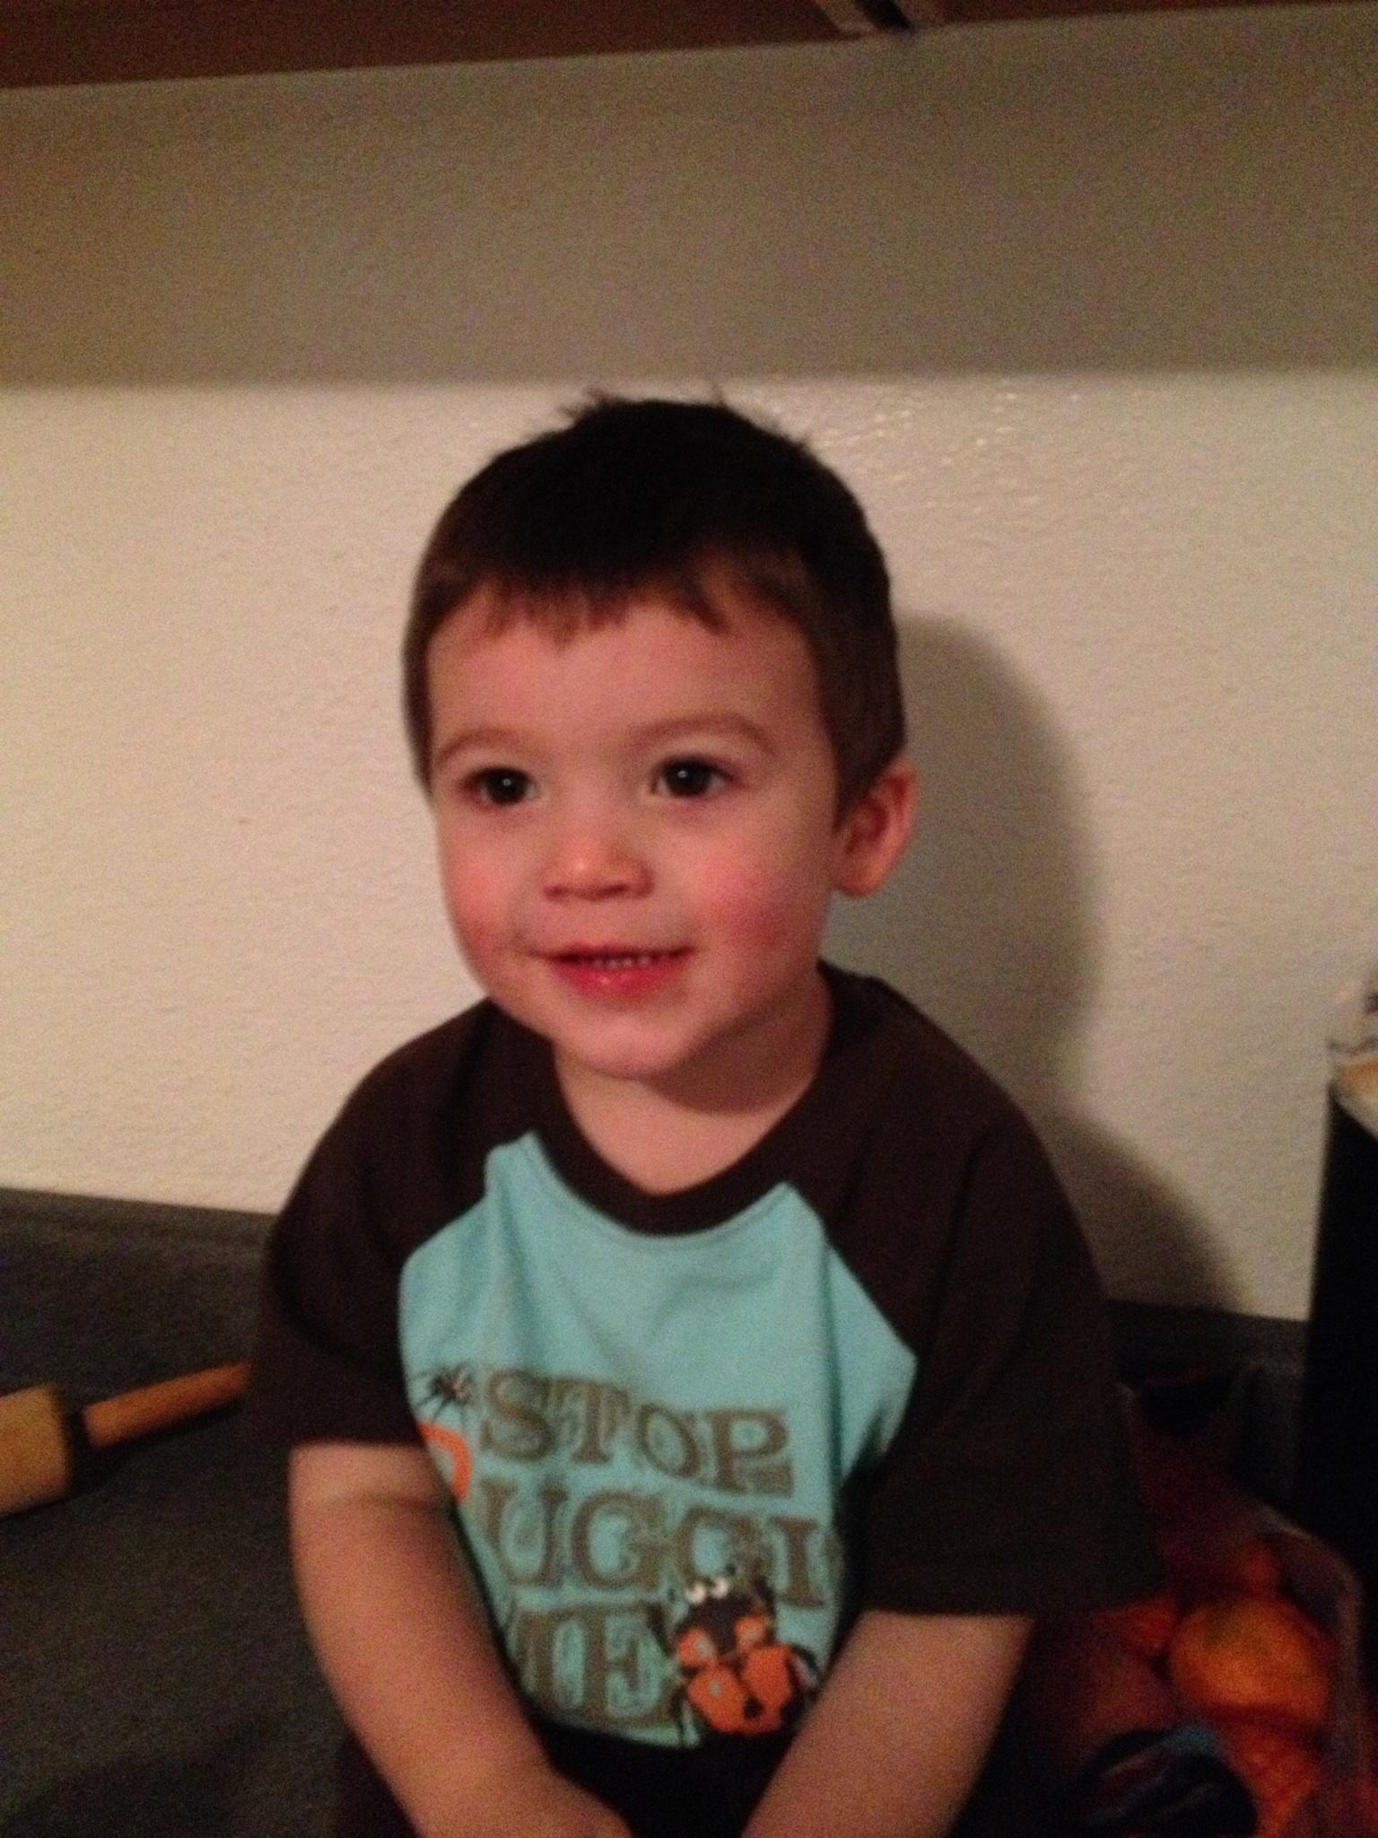 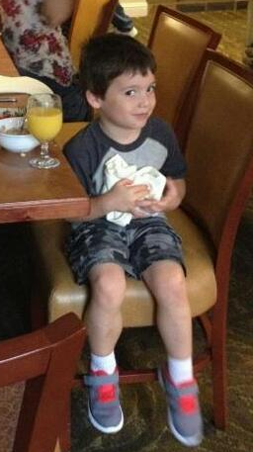 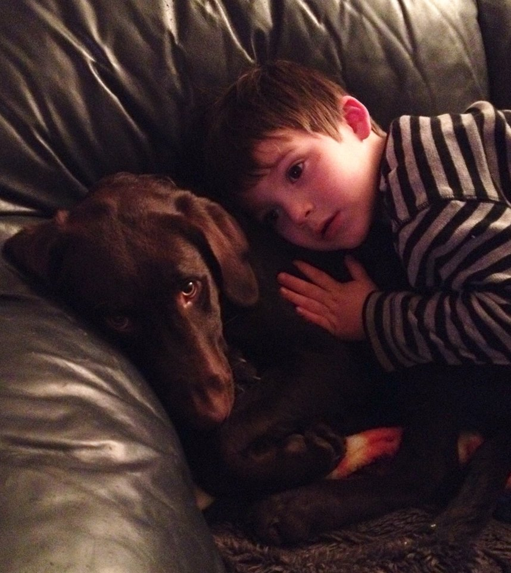
Margie and Dylan. (1 hour old). Born Feb 4, 2011.
Our daughter, Melissa.
Melissa & Margie
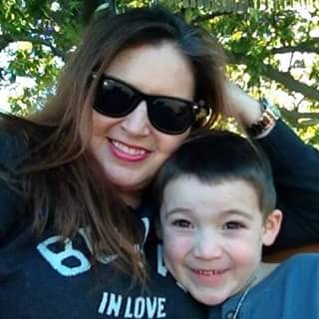
Melissa & Dylan
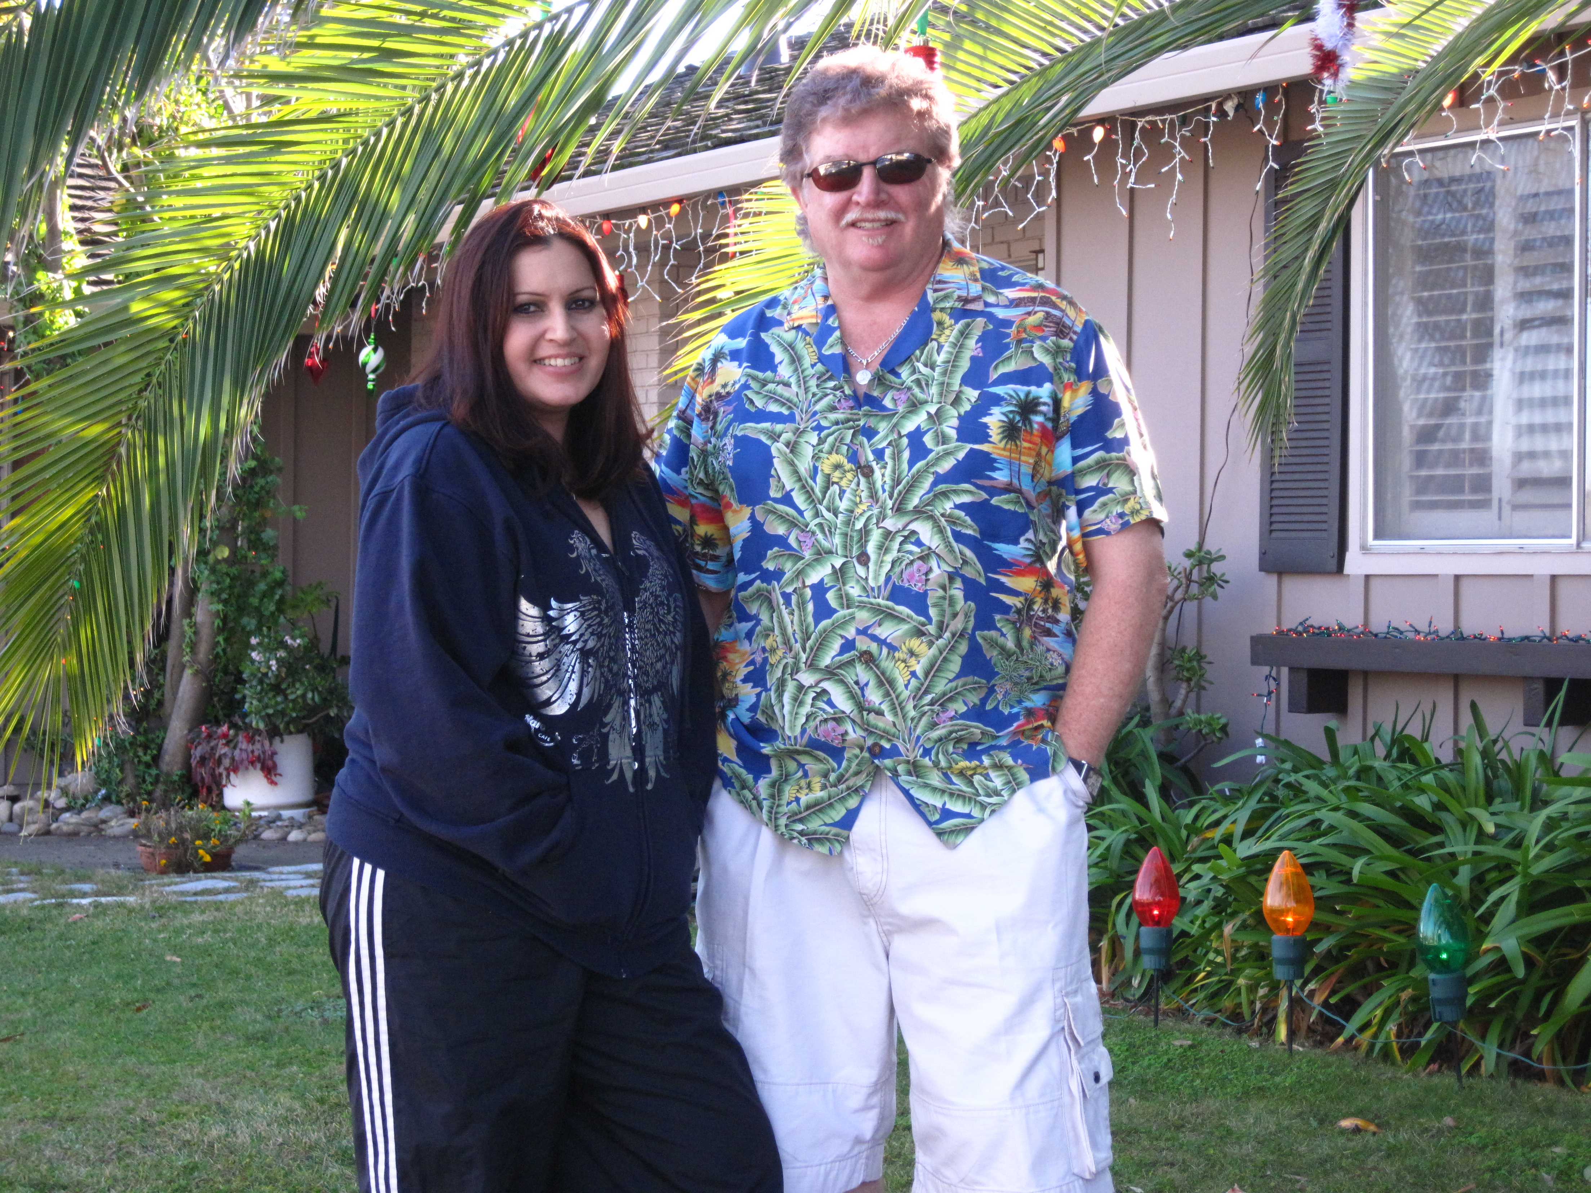
Melissa & Me
We really miss our boy, Indy.
Went to doggie heaven Jul 8, 2004. Age 12 1/2.
Click BELOW to see TRUE LOVE!
Windows Media Video (wmv)
Mpeg video (mpg)
Real Media video (rm)
Quicktime Video(avi)
Our new puppy, Gunner.
Born July 27, 2015
(Yep – he looks like Indy!)
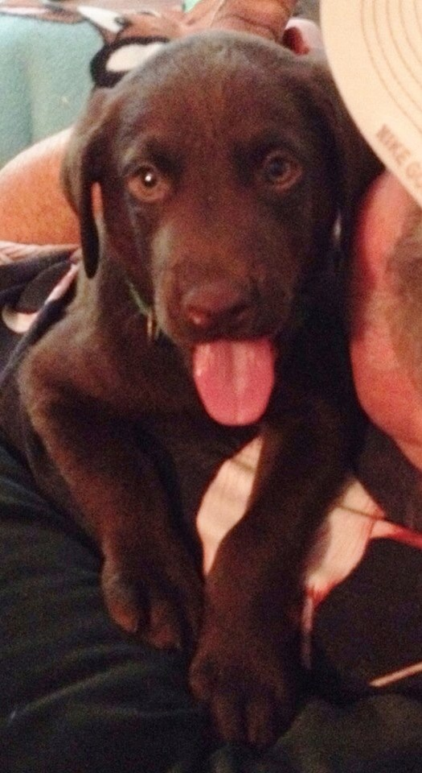
Here are some of my favorite memories of our early days...
Margie & me 1976. Margie, Melissa & Snoopy...1976.

Margie, Sunset Beach, Hawaii, 1981.

One of our first dates at the Santa Cruz Boardwalk...1976...Another satisfying kiss!
What a "cradle robber" I am.
Me & Margie 1976
I love Margie because...
She is sweet,
beautiful,
shy,
kind to old people,
kind to strangers,
kind of weird,
is a crack shot with her pink rifle,
likes small animals,
likes big animals,
likes kids,
likes my cooking,
loves her GIANTS,

loves a cold day at the beach,
(Santa Cruz )
loves a warm day at Napili
Beach sunsets
is energetic,
courageous,
spontaneous,
fun,
happy,
goofy,
perky,
has that "voice",
can talk about anything at length,
makes friends everywhere,
finds beauty in everything,
loves her pool,
makes piles,
collects Trolls,
collects Swatches,
collects sheet music,
collects Hawaiiana,
collects Disney stuff,
collects Hard Rock pins,
collects squashed pennies,
collects books,
collects shoes,
collects everything,
is a good kisser,
is never lost,
hates GPS,
digs her Caddy,
is always late,
is the 2nd biggest back-seat driver in the world,
can't say "no" to kids,
is colorful,
witty,
hibernates when she sleeps,
is in tune with reality but lives in a fantasy world,
is a dreamer,
never forgets,
loves a windy day at Coney Island,
loves sushi,
is there in a crisis,
has a good heart,
is soulful,
sticks to her guns,
and always has plenty of ammo.
But most of all...
Because she's Margie.
"Hey! You lookin' at me?"
HAPPY
VALENTINE
BIRTHDAY
MARGIE!
I LOVE YOU!
How the hell did I get so lucky?
Must be my BIG ...
Piano.
Your Lucky Hubby, Donnie.
Here's a song I wrote for Margie
shortly after I met her in 1976.
"LADY LOVE"
TURN ON YOUR SPEAKERS
AND CLICK HERE
3.9 MB MP3
Me and Margie a hundred years ago.
Visit Margie on FaceBook...
http://www.facebook.com/margiez55

Guess where I am?
You can e-mail MARGIE at:
margiez55@aol.com
YOU STEER!
MARGIE HAS A RARE KIDNEY DISEASE CALLED FSGS.
PRAY FOR HER TO GET WELL SOON!
(c) 2016

Margie, Margie, Margie, Valentine, Valentine, Valentine, Birthday, Bi
index.docrthday, Birthday, Love, Love, Love

